
Curriculum Vitae
- PERSONAL INFORMATION
First Name : Pamela
Middle Name : Galvez
Last Name : Marquez
Address : Calmay Laoac, Pangasinan
Birth date : August 8, 2003
Gender : Female
Status : Single

- EDUCATIONAL ATTAINMENT
Elementary School : Cabanbanan Elementary School
Year Graduated : 2016
Junior High School : Manaoag National High School
Highschool
Year Graduated : 2020
Senior High School : Manaoag National High School
Highschool
Year Graduated : 2022
Tertiary : Urdaneta City University
Motto : Everything happens for a reason

Curriculum Vitae
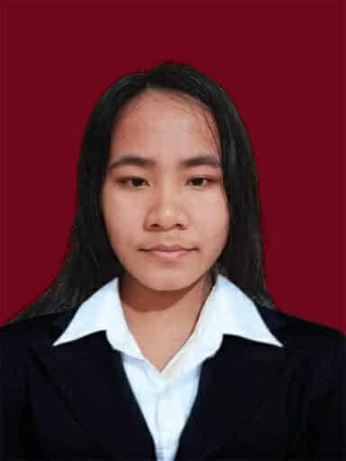
- PERSONAL INFORMATION
First Name : Jean Kyla
Middle Name : Mabitasan
Last Name : Garcia
Address : Cal-litang Santa. Maria,
Pangasinan
Birth date : June 28, 2004
Gender : Female
Status : Single

- EDUCATIONAL ATTAINMENT
Elementary School : Cal-litang Elementary School
Year Graduated : 2016
Junior High School : Eastern Pangasinan Agricultural
Year Graduated : 2020
Senior High School : Eastern Pangasinan Agricultural
Year Graduated : 2022
Tertiary : Urdaneta City University
Motto : “Believe you can and you’re half way
there.”

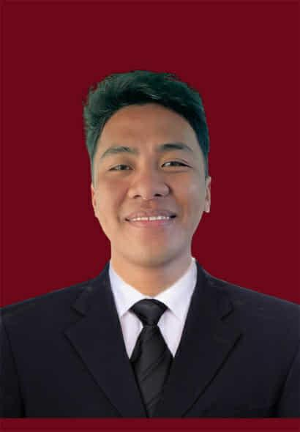
Curriculum Vitae

- PERSONAL INFORMATION
First Name : Franklin Cloyd
Middle Name : Agustin
Last Name : Jacinto
Address : Inamotan Manaog,
Pangasinan
Birth date : December 31, 2003
Gender : Male
Status : Single

- EDUCATIONAL ATTAINMENT
Elementary School : St. Camillus College of Manaoag
Foundation Inc.
Year Graduated : 2016
Junior High School : St. Camillus College of Manaoag
Foundation Inc.
Year Graduated : 2020
Senior High School : St. Camillus College of Manaoag
Foundation Inc.
Year Graduated : 2022
Tertiary : Urdaneta City University
Motto : "If you can’t survive, just try."

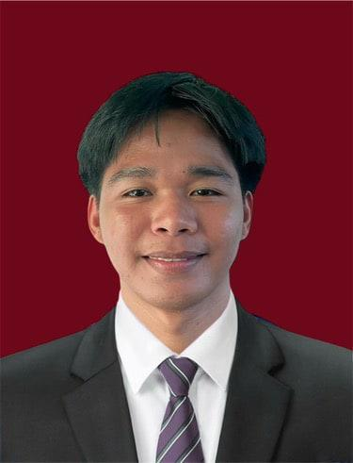
Curriculum Vitae

- PERSONAL INFORMATION
First Name : Mark Christopher
Middle Name : Macanas
Last Name : Lagundi
Address : Oltama, Urdaneta City,
Pangasinan
Birth date : January 4, 2004
Gender : Male
Status : Single

- EDUCATIONAL ATTAINMENT
Elementary School : Oltama Elementary School
Year Graduated : 2016
Junior High School : Cabaruan National High School
Year Graduated : 2020
Senior High School : Cabaruan National High School
Year Graduated : 2022
Tertiary : Urdaneta City University
Motto : "If you can’t survive, just try."

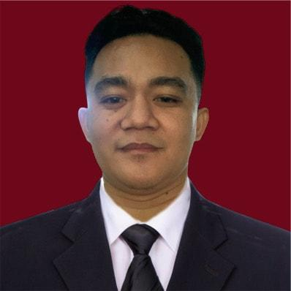
Curriculum Vitae

- PERSONAL INFORMATION
First Name : Aedriel Kenneth
Middle Name : Almuete
Last Name : Flores
Address : Ungab Cuyapo, Nueva Ecija
Birth date : June 26 2000
Gender : Male
Status : Single

- EDUCATIONAL ATTAINMENT
Elementary School : Olra College Foundation
Year Graduated : 2010
Junior High School : Olra College Foundation
Year Graduated : 2016
Senior High School : Olra College Foundation
Year Graduated : 2018
Tertiary : Urdaneta City University
Motto : "Try and Try until you succeed."

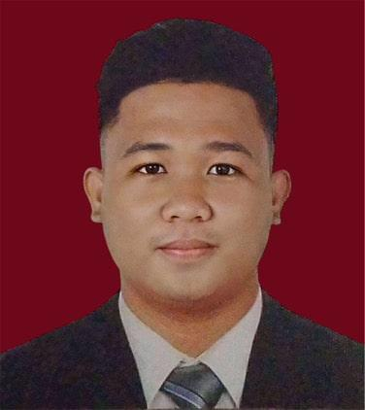
Curriculum Vitae

- PERSONAL INFORMATION
First Name : John Miko
Middle Name : Telin
Last Name : Almojera
Address : Nancayasan, Urdaneta City,
Pangasinan
Birth date : June 17,1998
Gender : Male
Status : Single

- EDUCATIONAL ATTAINMENT
Elementary School : Nancayasan Elementary School
Year Graduated : 2010
High School : Mariano Q. Umipig National
High School
Year Graduated : 2015
Tertiary : Urdaneta City University
Motto : “In God We Trust”

